Case Study: E-Commerce Analytics with AI-Assisted SQL, dbt & Snowflake
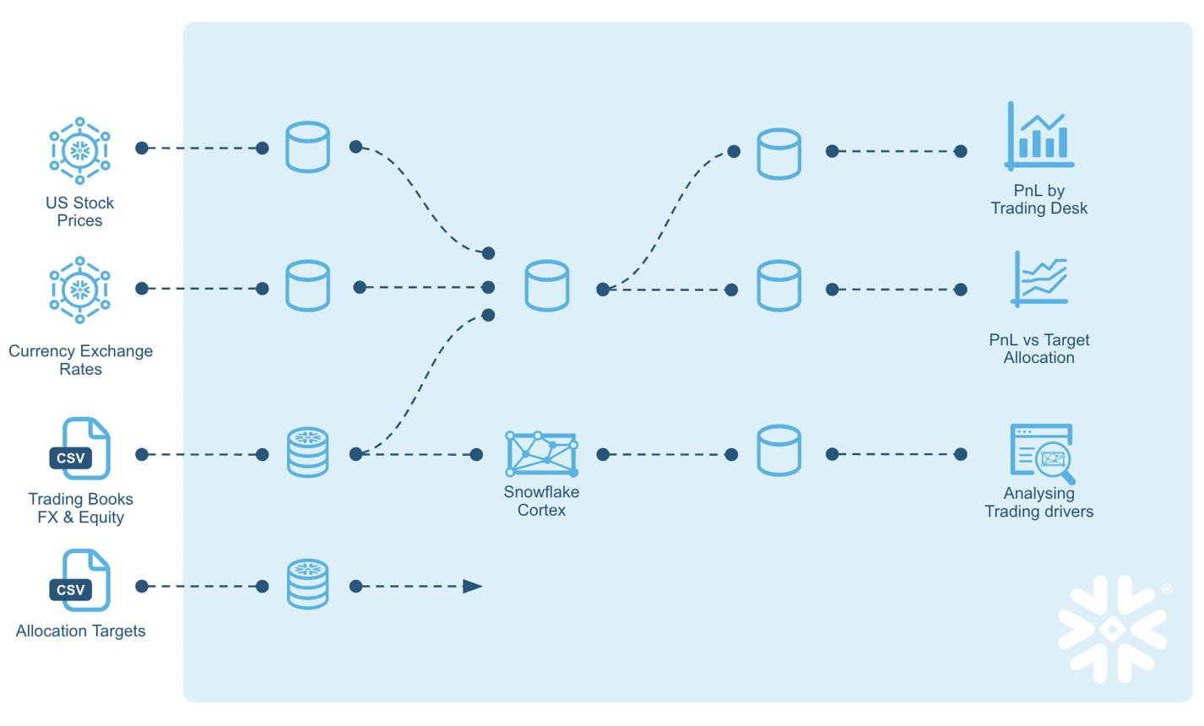
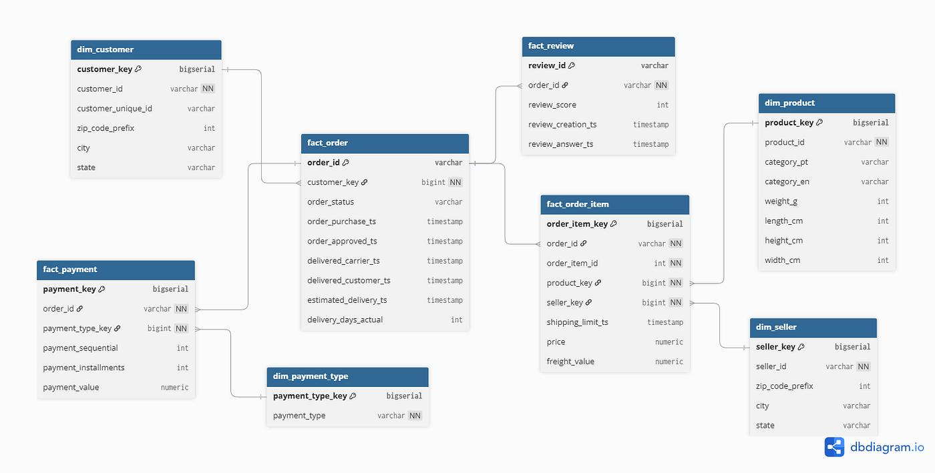
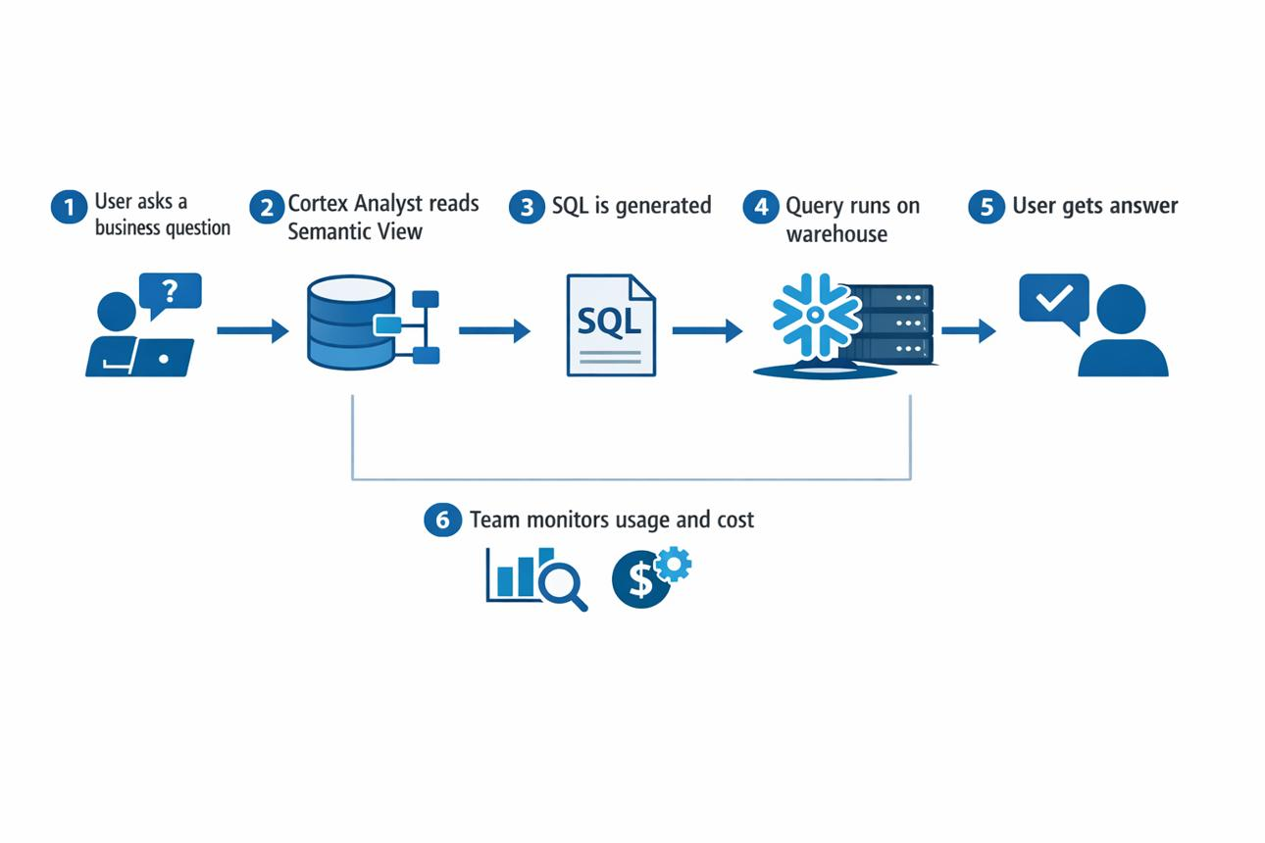
This is a real-world, trainer-level case study combining:
- Dimensional Modelling
- dbt (models + tests)
- AI-assisted SQL (open source)
- SQL Code Review
- NL2SQL (Snowflake Cortex-style)
You will use:
- Snowflake
- dbt Core
- Ollama + Code Llama
- SQLFluff

1) Business Context
Company: ShopKart (E-Commerce Platform)
Business Problems
- No unified analytics layer
- Slow reporting
- Data inconsistencies
Key Questions
- Who are top customers?
- Which products generate highest revenue?
- Revenue by region/category/month

2) Architecture (Modern Data Stack)
Raw Data → Snowflake → dbt → Tested Models → AI (Ollama / Cortex) → Insights
↑
SQL Review Agent

3) Step 1: Raw Data Setup (Snowflake)
Tables
CREATE TABLE customers (
customer_id INT,
name STRING,
region STRING,
signup_date DATE
);
CREATE TABLE products (
product_id INT,
product_name STRING,
category STRING,
price NUMBER
);
CREATE TABLE orders (
order_id INT,
customer_id INT,
product_id INT,
order_date DATE,
quantity INT,
amount NUMBER
);

Insert Sample Data (Include bad data)
INSERT INTO customers VALUES
(1,'Alice','North','2023-01-01'),
(2,'Bob','South','2023-02-01');
INSERT INTO products VALUES
(101,'Laptop','Electronics',1000),
(102,'Shoes','Fashion',200);
INSERT INTO orders VALUES
(1001,1,101,'2024-01-01',1,1000),
(1002,2,102,'2024-01-02',2,400),
(1003,NULL,101,'2024-01-03',1,1000); -- BAD DATA

4) Step 2: Dimensional Modelling
Star Schema
Fact Table
- fact_orders
Dimension Tables
- dim_customer
- dim_product
- dim_date (optional)

Grain Definition (IMPORTANT)
One row = one order transaction

5) Step 3: dbt Project Setup
dbt init ecommerce_project
cd ecommerce_project

sources.yml
version: 2
sources:
- name: raw
database: YOUR_DB
schema: PUBLIC
tables:
- name: customers
- name: products
- name: orders

6) Step 4: Staging Models
stg_orders.sql
SELECT
order_id,
customer_id,
product_id,
order_date,
quantity,
amount
FROM {{ source('raw','orders') }}

stg_customers.sql
SELECT customer_id, name, region FROM {{ source('raw','customers') }}

stg_products.sql
SELECT product_id, product_name, category FROM {{ source('raw','products') }}

7) Step 5: Dimension Models
dim_customer.sql
SELECT DISTINCT customer_id, name, region
FROM {{ ref('stg_customers') }}

dim_product.sql
SELECT DISTINCT product_id, product_name, category
FROM {{ ref('stg_products') }}

8) Step 6: Complex 3-Join Analytics Query
SELECT
c.customer_id,
c.name,
p.category,
SUM(o.amount) AS total_revenue,
COUNT(o.order_id) AS total_orders
FROM orders o
JOIN customers c ON o.customer_id = c.customer_id
JOIN products p ON o.product_id = p.product_id
GROUP BY c.customer_id, c.name, p.category
ORDER BY total_revenue DESC;

9) Step 7: AI-Assisted SQL (Ollama)
Explain Query
Prompt:
Explain this SQL in business terms:
Optimize Query
Prompt:
Optimize this SQL query for performance:

Optimized Query
SELECT
o.customer_id,
c.name,
p.category,
SUM(o.amount) AS total_revenue,
COUNT(*) AS total_orders
FROM orders o
JOIN customers c ON o.customer_id = c.customer_id
JOIN products p ON o.product_id = p.product_id
GROUP BY o.customer_id, c.name, p.category

10) Step 8: SQL Code Review (SQLFluff)
sqlfluff fix query.sql

11) Step 9: Convert to dbt Model
fact_customer_revenue.sql
SELECT
o.customer_id,
c.name,
p.category,
SUM(o.amount) AS total_revenue,
COUNT(*) AS total_orders
FROM {{ ref('stg_orders') }} o
JOIN {{ ref('dim_customer') }} c
ON o.customer_id = c.customer_id
JOIN {{ ref('dim_product') }} p
ON o.product_id = p.product_id
GROUP BY o.customer_id, c.name, p.category

12) Step 10: dbt Testing
schema.yml
version: 2
models:
- name: fact_customer_revenue
columns:
- name: customer_id
tests:
- not_null
- relationships:
to: ref('dim_customer')
field: customer_id
- name: total_revenue
tests:
- not_null
- name: category
tests:
- not_null

13) Step 11: Run Pipeline
dbt run
dbt test

14) Expected Failures
Issue | Reason
NULL customer_id | bad data
relationship fail | missing key
test failure | ensures quality

15) Step 12: Fix Data
DELETE FROM orders WHERE customer_id IS NULL;
Re-run:
dbt test

16) Step 13: NL2SQL (Snowflake Cortex Style)
Ask:
“Top customers by revenue”
SQL Generated:
SELECT customer_id, SUM(amount)
FROM fact_customer_revenue
GROUP BY customer_id;

17) Final Deliverables
dbt Models
- staging
- dimensions
- fact
Tests
- not_null
- relationships
AI Outputs
- Query explanation
- Optimized SQL

18) Business Impact
- Faster analytics
- Clean data layer
- Self-service reporting
- Reduced engineering effort

